Place Value Cards
This card games is for 2 players, or a small group.
You will need:
- A deck of cards with the 10s and picture cards removed
- The Ace can be used as a 1 in this game
- A sheet of paper split into 4 columns, labelled thousands, hundreds, tens and ones.
How to Play:
- One player to shuffle the deck of cards and place it in the middle, face down.
- Take it in turns to pick a card from the top of the deck and turn it over.
- The player must decide where to place the card, either in the ones, tens, hundreds or thousands place. Add the card to your piece of paper. The card is to be placed before another card is drawn from the pack.
Thousands  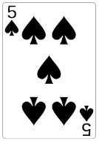 | Hundreds  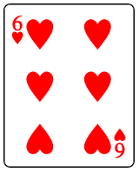 | Tens | Ones  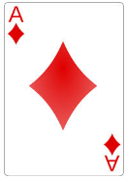

- Players keep adding cards to their sheet of paper until all columns are filled in. The winner is the player who produces the largest number.
- In the example shown, 5631 was produced using the cards 5, 6, 3 and the Ace. The best number that could have been formed was 6531.
Thousands | Hundreds | Tens  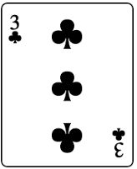 | Ones
Variations:
- You could make larger or smaller numbers
- Use numbers with decimals (think about money)
- Introduce a scoring system
- Calculate the difference between the two numbers created

21 or Bust!
This card games is for 2 players, or a small group.
The aim of this game is to get as close to, if not make, the number 21.
In this game, the Ace = 1; Jack = 11; Queen = 12; King =13 and the Joker = 21.
How to Play:
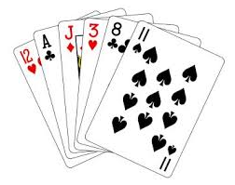
- Shuffle you deck of cards and lie them face down.
- Take it in turns to choose a card.
- Continue to pick up cards, without letting the other player(s) see. Call STOP when you have reached 21, or think you cannot safely pick up another card without going over the target.
- Make sure both players have the same number of cards before you show each other your hand. The player closest to 21 wins.
- If your cards add up to more than 21, you have gone bust!

Tens
This card games is for 2 players, or a small group.
You will need:
A deck of cards with the Joker and picture cards (Jack, Queen and King) taken out.
How to play:
- Spread the cards face down into 4 rows of 5.
- Take it in turns to turn over 2 cards. The other players are allowed to see what the cards are.
- If the cards you have turned over add up to 10, keep hold of your pair, and have a bonus turn.
- Turn the cards back over (face down) if they do not add up to 10.
- If you turn over a 10 first, keep hold of it and have a bonus turn. If you find the 10 on your second card, you must turn both cards back over.

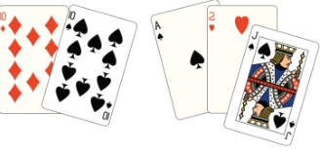
Variations:
- You could try to make a higher number e.g. 20 or perhaps 100!
- You could vary the number of cards each player is allowed to turn over in one turn.

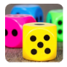
Dicey Operations

Find a partner and a 1-6 dice. Take turns to throw the dice and decide which of your boxes to fill. This can be done in two ways: either fill in each square as you throw the dice, or collect all your numbers and then decide where to place them.

Game 1
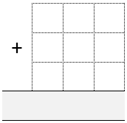
Each of you draw an addition grid like this:
Throw the dice nine times each until all the squares are full.

Whoever has the sum closest to 1000 wins.

There are two possible scoring systems:
- A point for a win. The first person to reach 10 wins the game.
- Each player keeps a running total of their "penalty points", the difference between their result and 1000 after each round. First to 5000 loses.
You can vary the target to make it easier or more difficult.

Game 2
Each of you draw a subtraction grid like this:
Throw the dice eight times each until all the cells are full.

Whoever has the difference closest to 1000 wins.

There are two possible scoring systems:
- A point for a win. The first person to reach 10 wins the game.
- Each player keeps a running total of their "penalty points", the difference between their result and 1000 after each round. First to 5000 loses.
You can vary the target to make it easier or more difficult, perhaps including negative numbers as your target.

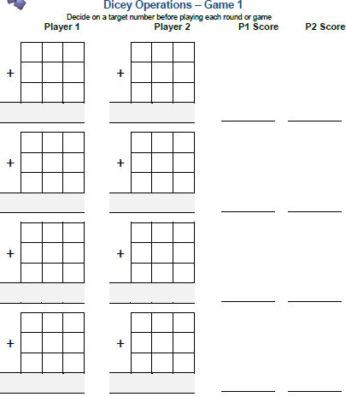

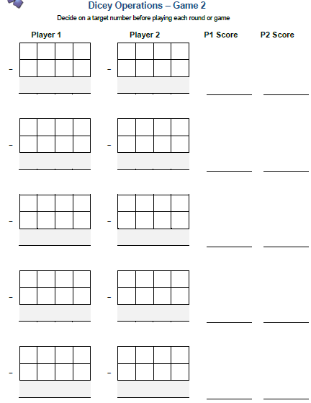

Dotty Six
You need a partner, a 1 -6 dice and a grid like this;
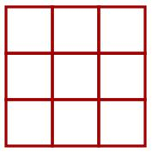
Take turns to throw the dice and draw that number of dots in one of the boxes on the grid.
Put all of your dots in one of the boxes. You can't split them up and you can't have more than six dots in a box.
When a box is full, you could put a tick in the corner like this:
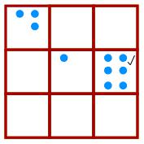
Keep going until there are three ticks in a row or column or diagonal. The winner is the person who puts the last tick.
Now, can you change the game to make your own version?

First Connect Three
You need:
- a partner
- a playing board
- two dice
- counters, two colours

In this game the winner is the first to complete a row of three, either horizontally, vertically or diagonally.
Roll the dice, place each dice in one of the squares and decide whether you want to add or subtract to produce a total shown on the board. Your total will then be covered with a counter.
You cannot cover a number which has already been covered. If you are unable to find a total which has not been covered you must Pass.
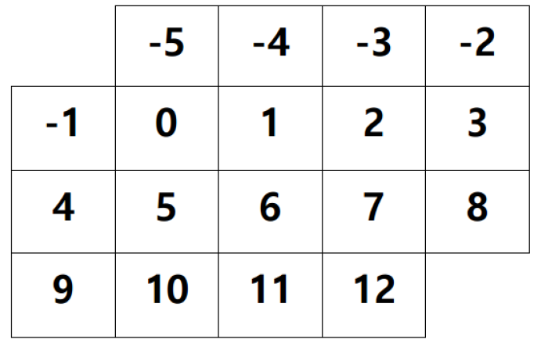
Are there some numbers that we should be aiming for? Why?
Which number on the grid is the easiest to get? Why?
Which number is the most difficult to get? Why?

