Year 3 Autumn 2 2020 Curriculum Overview
Grow Independence  Be responsible for completing reading, spelling and times tables practise at home 5 times a week | Contribute to Communities  Participate in a reverse advent calendar – food donations to Bromyard Food Bank  Samaritan’s- Operation Christmas Child |  | Promote Physical and Mental Health  Improve their scores on fitness exercises during circuits in P.E  Participate actively in Thrive sessions
Topic: The Age of Rock
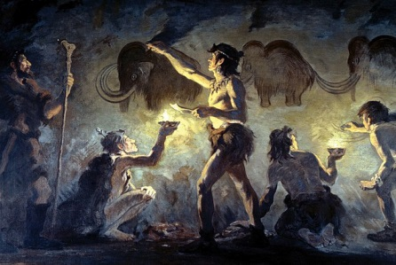
Continuous Provision: Homework activities to deepen understanding of Stone Age life. Tinker table with rock samples and questions to answers.
As historians we will:  Give a broad overview of life in Britain from ancient until medieval times.  Place events, artefacts and historical figures on a time line using dates.  Use evidence to ask questions and find answers to questions about the past.  Understand the concept of change over time, representing this, along with evidence, on a time line.  Use dates and terms to describe events.  Suggest causes and consequences of some of the main events and changes in history.  use appropriate historical vocabulary to communicate including: dates / time period / era / change / chronology. |  | As scientists we will: (OL)  Compare and group rocks. Investigate Physical properties of some rocks.  Describe fossils.  Investigate what soil is made up of.  Understand electrical circuits. | In PE we will:  Develop physical strength and suppleness by practising moves and stretching.  Show a kinesthetic sense in order to improve the placement and alignment of body parts (e.g. in balances experiment to find out how to get the centre of gravity successfully over base and organise body parts to create an interesting body shape).  Swing and hang from equipment safely (using hands).
As artists we will:  Use a number of brush techniques using thick and thin brushes to produce shapes, textures,  patterns and lines.  Explore ideas in a variety of ways |  | As geographers we will:  Human geography, including: settlements and land use. | As Design technologists we will:  Create series and parallel circuits. Control and monitor models using software designed for this purpose. Use software to design and represent product designs
Whole Class Reading Text:  Reciprocal Reading – “The Hundred Mile an Hour Dog” by Jeremy Strong |  | Talk4Writing Genres (English):  Extended Narrative  Poetry | Talk4Writing Genres (Cross Curric):  Non-chronological reports  Stone Age setting description
In PSHE (Thrive) we will:
Can work to others priorities as well as own. Help a child to develop the capacity to share and co-operate. Help a child to develop the capacity to share and co-operate. Can negotiate changes to rules and expectations assertively.

