Create a character description using figurative language.
Figurative language such as simile (comparing objects using ‘like’ or ‘as though’) and metaphor (stating two unlike objects are the same) is effective for describing subtle precise qualities and appearances.
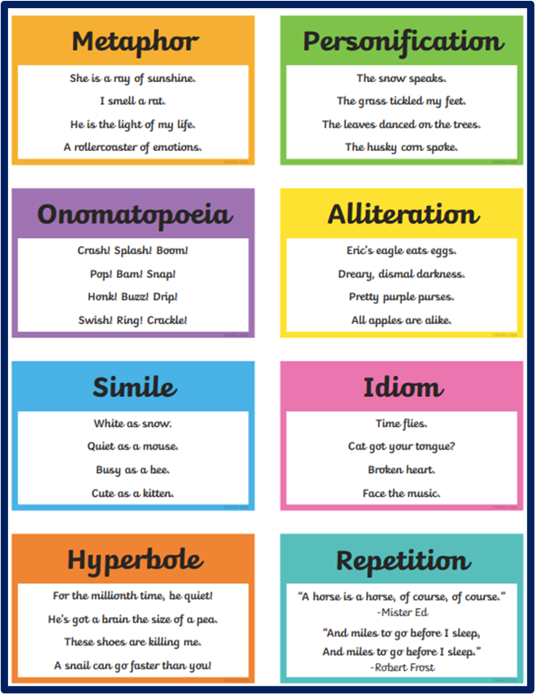
For example:
His dopey expression made him look as though he was always half-sedated.
Her thin, uptight mouth was a door on a latch, poised to shut fast at any sign of trouble or disagreement and stay that way ’til the coast was clear.

The first example (simile) conveys a character’s sleepy, befuddled appearance.
The second (a metaphor) gives us associations by stating one thing is another. The stand-in object (the latched door) tells us something about the first, the character’s mouth (in this case, the image suggests a mistrustful and conflict-averse person).
Pick one of the following characters and using the figurative language sheet and the examples above create a figurative character description of your chosen character.

- The Warden
- Luna Lovegood
- Luisa (from Encanto)
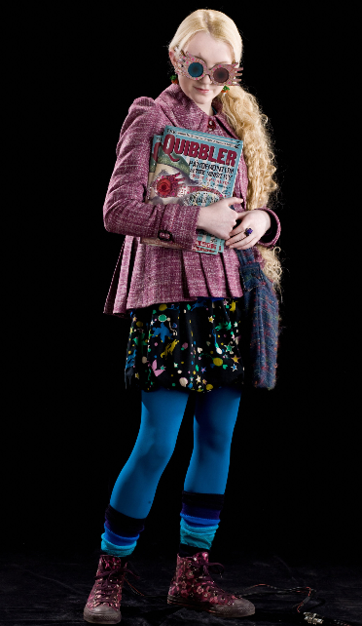
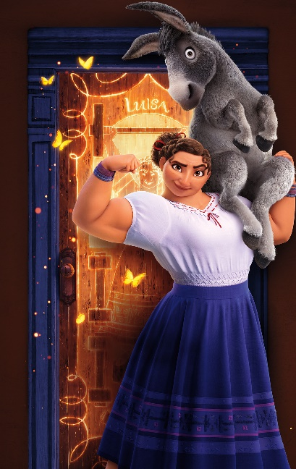
- Surf strider (Fortnight)

