Brockhampton Primary School Mission Statement and Vision

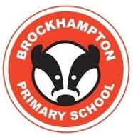

Inspiring every child to learn, grow and become all they can be

Every child matters. Every child deserves the best possible start in life and we are dedicated to providing this.

Every child is full of limitless possibilities waiting to be discovered, and we share your ambition for, and expectations of, the role school should play in that discovery.

We place every child at the heart of all we do. We empower our children with the confidence and resilience to explore their unique abilities and passions, and challenge them to excel, both now and in the future.

Inspiring every child to learn, grow and become all they can be

