 | Brockhampton Primary Academy
 | 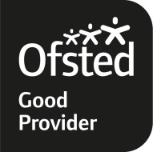 | Bringsty ~ WORCESTER ~ WR6 5TD  01885 483238  Email:office@brockhampton.hereford.sch.uk  www.brockhamptonprimaryschool.co.uk

Headteacher: Mr Matthew Mander
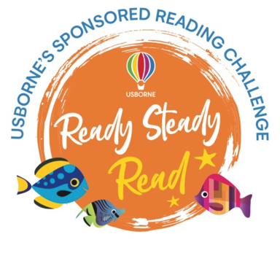


Dear parents/carers,
To celebrate and encourage a lifelong love of reading at home and school, we are running a sponsored read over the summer holidays between 21st July and 5th September.
The project is being organised in conjunction with our local Usborne Partner, Rosie’s Book Store, and all the money raised will go towards brand new books for our school. In addition to the sponsorship money, Usborne will also donate up to 60% of the total raised in extra free books to the school. So, for every £600 raised, we will get an extra £360 in free books for the children to enjoy in school. Our target is to raise £800 in sponsor money which is just £4.70 per child. Our aim is to use this money to purchase a wider range of topic-related books, particularly non-fiction, for all children to enjoy in class.
We would love to see as many children as possible reading over the summer holidays. Children can read to themselves, to others or to their pets and can choose from books, comics, magazines, newspapers, websites, recipes, poems, leaflets-anything with words! If you are able to support our sponsored read, please fill out the sponsorship form and reading log. If you need additional copies of the forms, this letter and all attachments can be found on the school website under Learn, English, Ready, Steady, Read. All sponsor money should be sent into school by Friday 8th September in a named envelope. Cash or cheque accepted-please make cheques payable to Rosanna Mackay.
We look forward to hearing about the books you have read over the summer. If you would like any more information on the sponsored read then please contact Mrs Jones or Rosie Mackay at Rosie’s Book Store on the following contact details; 07552951470, rosie@rosiesbookstore.co.uk, Facebook@Rosiebookstore.
In addition to this, the PTA have created a KS1 and KS2 BINGO board for children to work through over the summer holidays. If you would like to take part in this, ask an adult to date a sign each square of the BINGO board and return it to your class teacher by Friday 8th September. Each completed KS1 entry will be entered into a draw to win a teddy bear and each completed KS2 entry will be entered into a draw to win a book token.
Happy reading!
Kind regards,
Mrs Jones

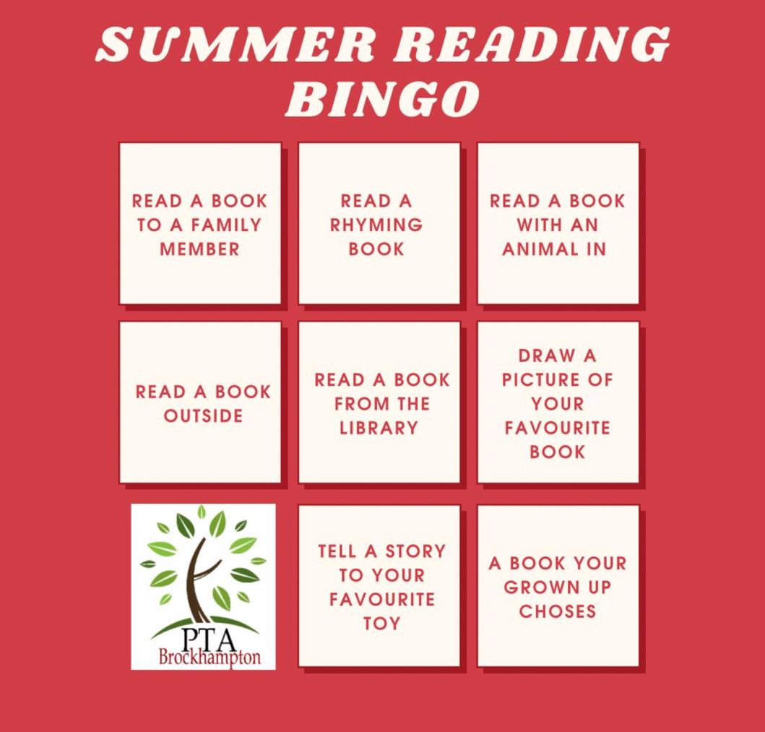
KS1 BINGO Board

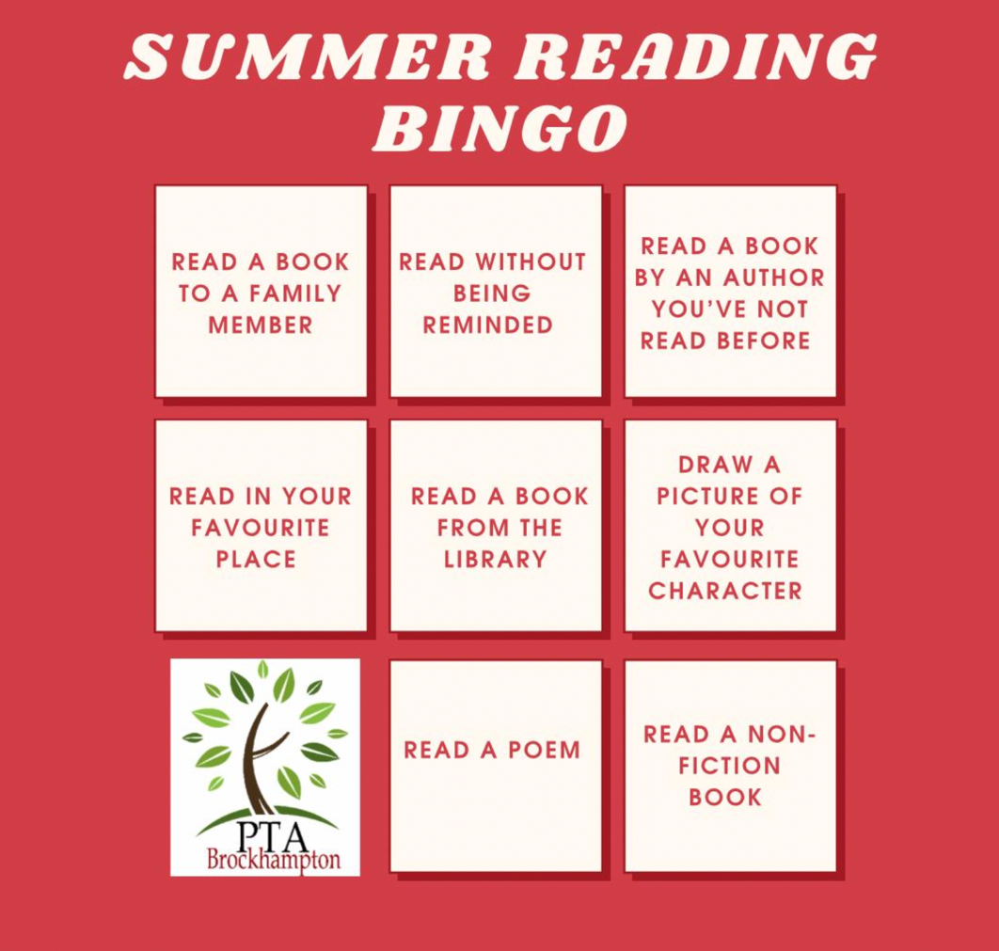
KS2 BINGO Board

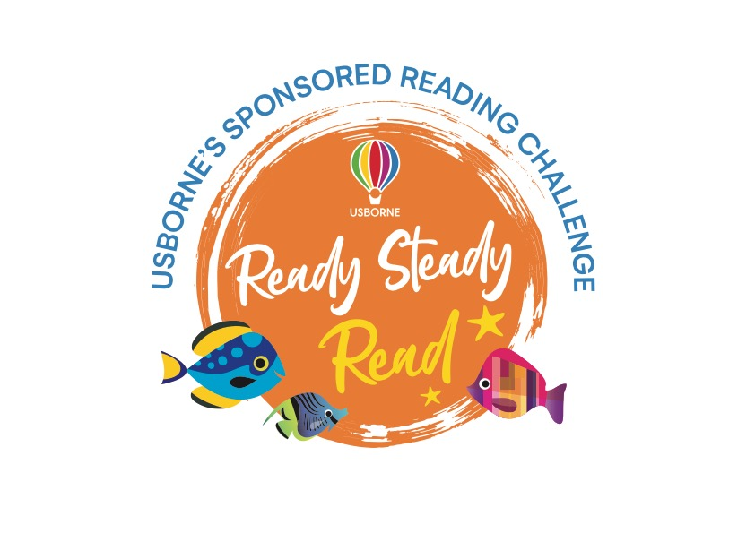

Reading Log

Pupil name: Year:

Date | What did you read? | Number of minutes spent reading

Total minutes spent reading:

Sponsorship Form

Pupil name: Year:
Name of sponsor | Sponsorship (per minute or total donation) | Total amount collected

Total amount raised:

Please return this form along with your sponsorship money and reading log to school by Friday 8th September.
Thank you for your support

